

Department | FED
Subject | DSA-2
Academic Year | I-III Semester (2025-26)
Faculty Name | Mohammad Razia Alangir Banu
Student Name | Mohammad Zaid Amaan
Roll Number | 2520030382
Branch | CSE
Course Outcome | CO-1

Case Study Topic: MediFlow Hospital — Appointment-Driven Patient Indexing using AVL Tree

Work Done Summary:

In this case study, we implemented an AVL Tree for MediFlow Hospital's triage console patient index. Patient IDs arrive in near-sorted appointment order (adversarial for a plain BST).
The AVL Tree self-balances on every insert and delete using Left-Rotate and Right-Rotate operations, keeping the tree depth at 4 for 13 keys — well within the 25-level SLA
ceiling (p99 < 5 ms at ~200 ns/dereference). We inserted 13 morning IDs, performed 3 noon deletions, and verified point-lookups.

Implementation Details:

- Inserted 13 Patient-IDs into AVL Tree in appointment (near-sorted) order.
- Maintained balance using Left-Rotate (RR case) and Right-Rotate (LL case) after each insertion.
- Performed rotations whenever balance factor exceeded +1 or fell below -1.
- Deleted 3 noon patients (30-transferred, 70-discharged, 50-closed) with re-balancing.
- Verified point-lookups: search(65) FOUND, search(30) NOT FOUND, search(85) FOUND.
- Confirmed AVL depth = 4 satisfies SLA (4 × 200 ns = 800 ns << 5 ms).

Result: Screenshots / Output

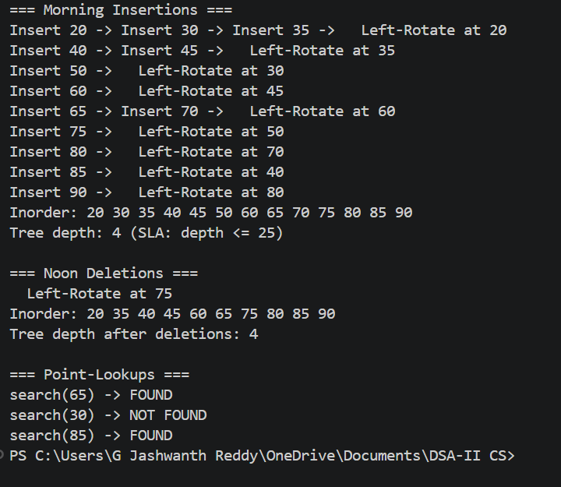

GitHub Link: https://github.com/zaid858/CO1

Student Signature | Faculty Signature

